ComicsWorld

**Software Development Plan (Small Project)**

**Version 1.**2

**Revision History**

| **Date** | **Version** | **Description** | **Author** |
| --- | --- | --- | --- |
| 21/06/23 | 1.0 | Propose part 4.2: Project plan  Updated part 3 | Nguyễn Trần An Hoà  Phạm Phú Toàn  Tô Khánh Linh |
| 26/06/23 | 1.1 | Full fill part 1, part 2, part 4.1 | Phạm Phú Toàn |
| 30/06/23 | 1.2 | Part 4.2 (gantt chart) | Nguyễn Trần An Hòa |
| 06/07/2023 | 1.3 | Part 4.2 (gantt chart)  Part 4.3.3 | Tô Khánh Linh |

**Table of Contents**

**1. Introduction** 4

1.1 Purpose 4

1.2 Scope 4

1.3 Overview 4

**2. Project Overview** 4

2.1 Project Purpose, Scope, and Objectives 4

2.2 Assumptions and Constraints 4

2.3 Project Deliverables 4

**3. Project Organization** 5

3.1 Organizational Structure 5

3.2 Roles and Responsibilities 5

**4. Management Process** 5

4.1 Project Estimates 5

4.2 Project Plan 6

4.3 Project Monitoring and Control 9

4.3.1 Requirements Management 9

4.3.2 Reporting and Measurement 9

4.3.3 Risk Management 10

4.3.4 Configuration Management 10

**Software Development Plan (Small Project)**

# Introduction

The introduction of the **Software Development Plan** provides an overview of the entire document. It includes the purpose, scope, definitions, acronyms, abbreviations, references, and overview of this **Software Development Plan**.

## **Purpose**

The purpose of the *Software Development Plan* is to gather all information necessary to control the project. It describes the approach to the development of the software and is the top-level plan generated and used by managers to direct the development effort.

The following people use the *Software Development Plan*:

* The **project manager** uses it to plan the project schedule and resource needs, and to track progress against the schedule.
* **Project team members** use it to understand what they need to do, when they need to do it, and what other activities they are dependent upon.

## **Scope**

This *Software Development Plan* describes the overall plan to be used by the ComicsWorld project, including deployment of the product.  
The plans as outlined in this document are based upon the product requirements as defined in the *Vision Document*.

## **Overview**

This *Software Development Plan* contains the following information:

Project Overview — provides a description of the project's purpose, scope, and objectives.  It also defines the deliverables that the project is expected to deliver.

Project Organization — describes the organizational structure of the project team.

# Project Overview

## Project Purpose, Scope, and Objectives

ComicsWorld is a website for people who are comics authors that are unknown or amateur to share their works to readers in order to search for a chance to spread the comics to a variety of viewers and attract more and more publishers to recognize their potential. Also, ComicsWorld is a place to read thousands of different genres of comics to entertain, relax and find ideas and passion from other’s works.

## **Assumptions and Constraints**

Time required to complete: 2 months - 5 sprints.

Staff: 5 team members.

Budget: 20$ for web hosting.

Task achievement: The website needed to be developed with 3 roles demonstrated and at least 10 functions.

## **Project Deliverables**

The final deliverable is the comic website as specified above. Deliverables for each project phrase are identified in the Development Case. Deliverables are delivered towards the end of the iteration/sprint, as specified in section 4.2.4 Project Schedule.

# Project Organization

## Organizational Structure

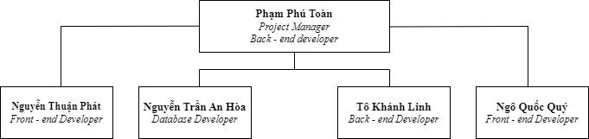

| Member | Role | Allocation |
| --- | --- | --- |
| Phạm Phú Toàn | Project Manager | 100% |
| Phạm Phú Toàn | Back - End Developer | 50% |
| Nguyễn Thuận Phát | Front - End Developer | 50% |
| Nguyễn Trần An Hòa | Database Developer | 100% |
| Ngô Quốc Quý | Front - end Developer | 50% |
| Tô Khánh Linh | Back - End Developer | 50% |

## Roles and Responsibilities

| **Person** | **Role** |
| --- | --- |
| Phạm Phú Toàn | Project Manager, Back-end Developer |
| Nguyễn Thuận Phát | Front - end Developer |
| Nguyễn Trần An Hòa | Database Developer |
| Ngô Quốc Quý | Front- end Developer |
| Tô Khánh Linh | Back - end Developer |

# Management Process

## **Project Estimates**

- Reader (Member - Guest): (29h - 44h)

* Sign in, sign up account (4h - 6h)
* Follow favorite comics (4h - 6h)
* Read Comics (6h - 8h)
* Comments (3h - 6h)
* Search comic (6h - 8h)
* Rate Comics (3h - 5h)
* Report bug/copyright violation (3h - 5h)

- Uploader: (18h - 24h)

* Create Comic (4h -6h)
* Upload Comics (each chapters) (6h - 8h)
* Track the number readers of comics, the report of their comic (8h - 10h)

- Admin: (21h - 29h)

* Grant or reject permission for uploader account (3h - 5h)
* Ban members account (4h - 6h)
* Remove Comics (6h - 8h)
* Track the number readers of comics, the report on the website (8h - 10h)

- Total:

* Time: 68h - 97h
* Cost: 1360$ - 1940$ (20$/h)

## Project Plan

**Sprint 1/PA1:**

- Start: 11:00 PM - 17/06/2023

- End: 11:00 PM - 08/07/2023

- Task:

Documenting:

* Project introduction: 3/7-6/7
* Project overview: 3/7-6/7
* Project organization: 18/6-23/6
* Project plan (outline): 18/6-23/6
* Project plan (gantt chart drawing): 3/7-6/7
* Project monitoring and control: 3/7-6/7
* Vision document: 18/6-6/7
* Writing weekly report: 24/6-25/6, 8/7

Training:

* Learning language

- Achievement:

* PA1 submission, knowledge of web coding.

**Sprint 2/PA2:**

- Start: 11:00 PM - 08/07/2023

- End: 11:00 PM - 22/07/2023

- Task:

Documenting:

* Write Use-case specification: 13/7-14/7, 17/7-20/7
* Revised project plan: 9/7-11/7
* Draw Use-case model: 17/7-20/7
* Writing weekly report: 15/7-16/7, 22/7

Training:

* Learning framework

- Achievement:

* PA2 submission, knowledge of web coding.

**Sprint 3 /PA3:**

- Start: 00:00 AM - 23/07/2023

- End: 11:00 PM - 05/08/2023

- Task:

Documenting:

* Revise (and complete) the Use-case specification: 23 - 25/07
* Revise (and complete) the Use-case model: 23 - 25/07
* Define software architecture: 26 - 30/07
* Draw class diagram: 28/7 - 4/08
* Propose/sketch UI for each screen: 2 - 5/08
* Weekly report: 28-29/07, 4-5/08

Training:

* Learning web protocol (28/7 - 5/08)

- Achievement:

* PA3 submission

**Sprint 4/PA4**

- Start: 00:00 AM - 06/08/2023

- End: 11:00 PM - 19/08/2023

- Task:

Documenting:

* Revise (and complete) software architecture document: 06 - 07/07
* Draw/Design UI based on proposal: 08 - 12/08
* Describe purpose for each screen: 08 - 11/08
  + Weekly report: 11-12/08, 18-19/08

Coding:

* Implement UI: 10 - 19/08
* Implement key features: 10 - 19/08
* Design and implement database model: 10 - 19/08

- Achievement:

* PA4 submission

**Sprint 5/PA5**

- Start: 00:00 AM - 20/08/2023

- End: 11:00 PM - 30/08/2023

- Task:

Documenting:

* Write test plan: 20 - 22/08
* Write test case report: 27 - 30/08
* Make slides presentation: 27 - 30/08
  + Weekly report: 25-26/08

Coding:

* Implement additional features (maybe): 20 - 23/08
* Design/implement test case: 23/08 - 27/08
* Run test case and fix bugs 25/08 - 28/08

- Achievement:

* PA5 submission, first release

(If there are PA6, one more release is expected)

* Sprints in detail:
  + Sprint 0:

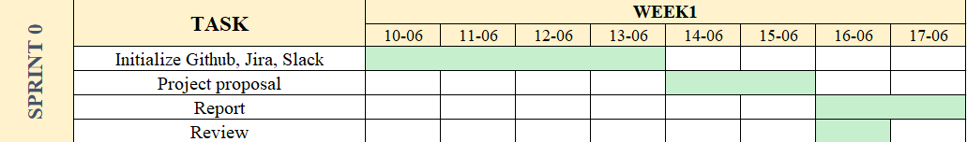

* + Sprint 1:
  + Sprint 2: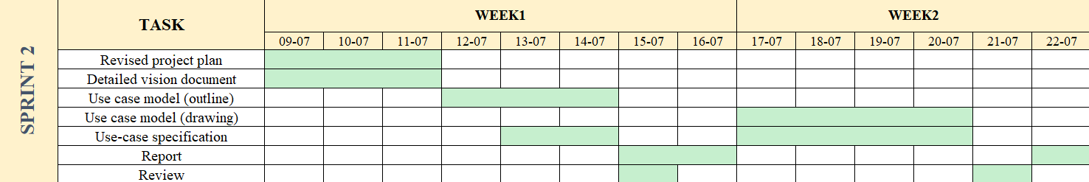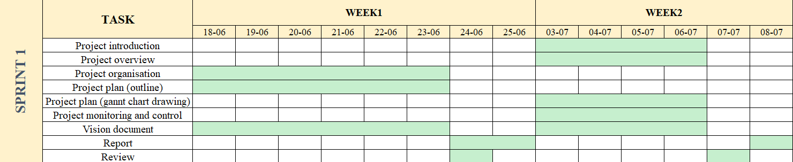

* + Sprint 3:

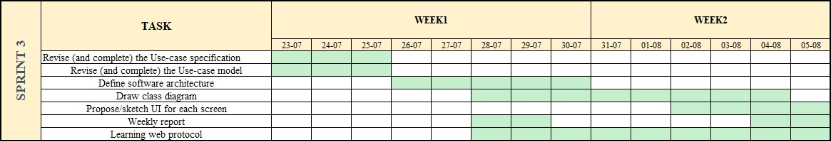

* + Sprint 4:

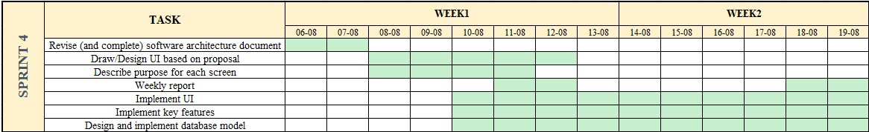

* + Sprint 5:

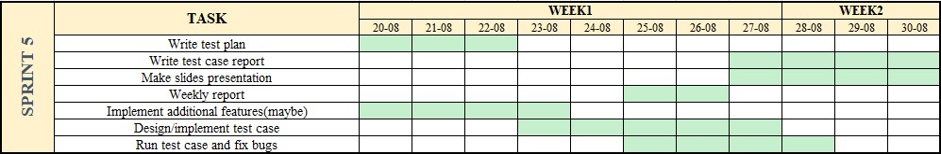

## **Project Monitoring and Control**

### *Requirements Management*

The requirements for this system are captured in the Vision document. Requested changes to requirements are captured in Change Requests, and are approved as part of the Configuration Management process.

### *Reporting and Measurement*

Updated cost and schedule estimates, and metrics summary reports, will be generated at the end of each iteration.

The Minimal Set of Metrics, as described in the RUP Guidelines: Metrics, will be gathered on a weekly basis. These include:

Earned value for completed tasks. This is used to re-estimate the schedule and budget for the remainder of the project, and/or to identify need for scope changes.

Total defects open and closed – shown as a trend graph. This is used to help estimate the effort remaining to correct defects.

Acceptance test cases passing – shown as a trend graph. This is used to demonstrate progress to stakeholders.

In addition, overall costs will be monitored against the project budget.

### *Risk Management*

Risks will be identified in the Inception Phase using the steps identified in the RUP for Small Projects activity “Identify and Assess Risks”. Project risk is evaluated at least once per iteration and documented in this table. The risks of the greatest magnitude are listed first in the table.

| **Risk Ranking (High, Medium, Low)** | **Risk Description and Impact** | **Mitigation Strategy and/or Contingency Plan** |
| --- | --- | --- |
| High | The time prediction to develop the website is longer than the actual time can lead to missed deadline | More overtime sessions, omit extended functions. |
| High | Differences of skill, idea between members lead to lack of communication, argument | Encourage members to ask questions and share their knowledge with each other, hold group meetings regularly. Lower the standard so everyone can fit in. |
| Medium | Member’s first time participating in a software project so it is challenging to plan and assign tasks | Divide Back- end and front- end separately for each member. |
| Medium | Difficulty in approaching technology, lack of coding skills in web-related language can lead to deadline delaying, poor staff morale | Ask the teacher for instruction, self-learning using online references. Create a group chat to share knowledge with each other. |
| Medium | Someone have health problem can affect the whole the team’s efficiency | Other members help that member finish their task. |
| Medium | The conflicts of code between member that can’t be merge affect the whole team efficiency | Have a clear initial guideline and plan such as functions, classes and the input or output of each code segment to prevent the conflicts. Have the meeting review to solve when conflicts happen. |
| Low | Unexpected incident happens cause code and work losing | Use an online repository provider to store code on cloud, every member is encouraged to store a version of the project in their laptop, and contribute commits to the project's repository when they update code. |

### *Configuration Management*

Appropriate tools will be selected which provide a database of Change Requests and a controlled versioned repository of project artifacts.

All source code, test scripts, and data files are included in baselines. Documentation related to the source code is also included in the baseline, such as design documentation. All customer deliverable artifacts are included in the final baseline of the iteration, including executables.